**NAME: K. MAYURI  
REG NO: 192372104  
  
Push in git:**

1. Create one new folder named git using mkdir git command  
     
   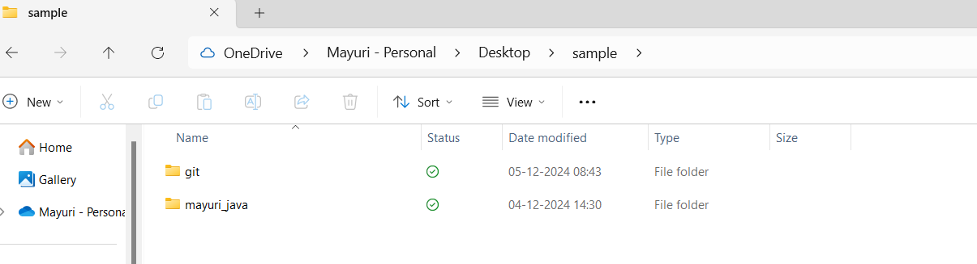
2. Create a new file named file.txt under the new folder using echo “hello world” >> file.txt.

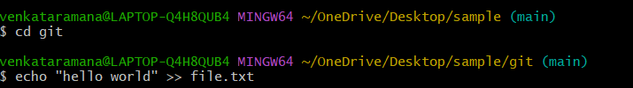

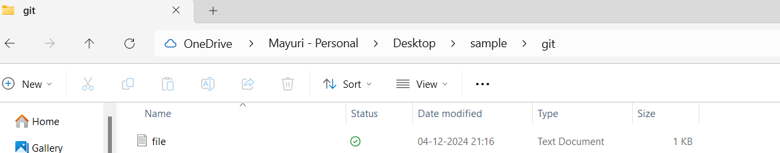

3.Give username and user email configuration as shown:

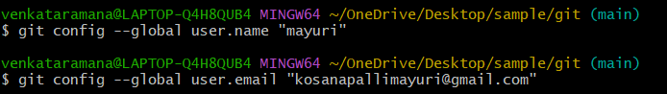

4.Confirm the configuration:

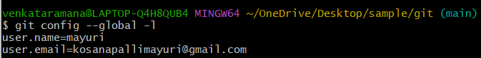

5.Initialize a New Repository in this folder using git init. Here new repository is .git.



6.Verify the new repository in folder